Software Requirements Specification

for

Voice Translation App

Version 1.0

Prepared by

Group Name: <*Enes’s Team*>

|  |  |  |
| --- | --- | --- |
| ENES KILIÇ | 2000006890 | 2000006890@stu.iku.edu.tr |
| FURKAN ÇELİK | 1800002521 | 1800002521@stu.iku.edu.tr |
| NİSA NUR ÇELİK | 1700003411 | 1700003411@stu.iku.edu.tr |
| ALİ YAMAN | 1700005265 | 1700005265@stu.iku.edu.tr |

|  |  |
| --- | --- |
| Instructor: | *AKHAN AKBULUT* |
| Course: | SYSTEM ANALYSIS AND HUMAN COMPUTER INTERACTION DESIGN |
| Lab Section: | *A* |
| Teaching Assistant: | *ARDA ARŞIK* |
| Date: | 28.05.2021 |

1.INTRODUCTION 5

1.1. PROBLEM Definition 5

1.2. Purpose 6

1.3. Scope 6

1.4. Objectives 9

1.5. Definitıons and abbreviatıons 10

1.5. REFERENCES 10

1.7. Roles and responsibilıtıes 11

1.7. overview 13

2.OVERALL DESCRIPTION .. 144

2.1. Product Perspective 14

2.2. Product Functionalities 15

2.3. Operating Environment 155

2.4. Constraints, Assumptions and Dependencies 16

2.5. namıng conventıons 166

2.5.1. document formattıng rules 166

2.5.2. app(coding) namıng conventıons 167

3. Requirements 17

3.1. Functional Requirements 177

3.2. Products Requirements 188

3.3. Data Requirements 188

3.4. Security Requirements **Hata! Yer işareti tanımlanmamış.**9

3.5. Performance Requirements 19

3.5. Usability Requirements 199

4. Non Functional Requirements 20

4.1. Performance Requirements 20

4.2. Safety and Security Requirements 21

4.3. Software Quality Attributes. 21

4.3.1. Usability 22

4.3.2. Reliability 22

4.3.3. Availability 22

4.3.4. Portability 23

4.3.5. Testability 23

4.3.6. Scalability 23

4.3.7. Flexibility 23

4.3.8. Reusability 23

4.3.9. Maintainability 23

4.3.10. Supportability 24

4.3.11. Interoperability 24

4.3.12. Performance 24

4.3.13. Security 24240

5. SYSTEM ARCHITECTURE AND ARCHITECTURAL DESIGN 24

5.1. SOFTWARE DEVELOPMENT METHODOLOGIES 25

5.1.1. WATERFALL 25

5.1.2. SCRUM 26

5.1.3. AGILE 26

5.2. LOGICAL VIEW 27

5.3. DEPLOYMENT VIEW 28

5.4. USE CASE VIEW 29

5.5. USE CASE SCENARIOS 36

6. DESIGN AND IMPLEMENTATION 41

**Revisions**

| Version | Primary Author(s) | Description of Version | Date Completed |
| --- | --- | --- | --- |
| 1.0 | Enes Kılıç | The entire content of this document has been prepared | 25/05/21 |

# INTRODUCTION

Voice Translation Application is basically a project in which verbal expressions are translated instantly and verbal feedback can be made in a second language.

The Voice Translation app first demonstrated speech translation as a concept exhibition at NEC Corporation, ITU Telecom World (Telecom '83) in 1983. In 1999, the C-Star-2 consortium demonstrated speech-to-speech translation of 5 languages, including English, Japanese, Italian, Korean, and German [[1]](https://en.wikipedia.org/wiki/Speech_translation). The first published voice translation application was Jibiggo in 2009. Jibbigo is an offline voice translator and does not need a phone or data connection to operate [[2]](https://en.wikipedia.org/wiki/Jibbigo). Today, there are many applications with advanced features. Some of these applications are; Google Translate, Microsoft Translator, iTranslate, Yandex Translate, OnCreen Translate, Copy Translate. [[3]](https://shiftdelete.net/android-icin-en-iyi-dil-ceviri-uygulamalari-57135)

Voice Translation Applications from past to present are used in different areas all over the world. These; factories, retail stores, schools, police, hotels, medical facilities ..

## Problem Definition

The main and the main purpose of the Voice Translation Application is to provide the equivalent of words, word groups or sentences that express meaning in a different language, both in written and voiced form. In this way, users can learn the relevant translation information in a faster and more practical way, and can also provide communication accordingly. With the developing technology, this application can be used in every sector that needs to be communicated in different languages. This project will greatly save time and reduce costs.

## Purpose

The purpose of this document is to determine the Voice Translation Application features, requirements, and interface. He / she will explain the scenario of the desired project and the necessary steps to be successful in the task. For implementation throughout this document, there will be a general description of the project, a description of the problem the project has solved, and project-related definitions and abbreviations. The preparation of this SRS will assist in considering all the requirements and needs before this project is put into operation, and will reduce later visual re-design, re-coding, retesting as much as possible. Thus, it greatly reduces the time, cost and work.

## Scope

The name of the project that will be presented in this document is Voice Translation Application. We tried to keep the scope of the project as wide as possible so that our application has many features. In this way, we aimed to provide our users with the best experience and convenience. For this purpose, we researched, examined, tested and evaluated all Voice Translation Applications.

We decided that it should be a mobile application because the project interface is not complicated, has a high level of mobility, and is used continuously, quickly and comfortably. In the project, we first needed an api to convert the sound to the device microphone into meaningful words and write it down. The best Api to choose is undisputed Google's Speech-to-Text Api [[4]](https://cloud.google.com/speech-to-text) . It supports all languages ​​in the world. He is very sensitive and very good at listening and understanding sound. Of course, however, we needed another API that could understand the meanings of these words in the most accurate way and translate them into a desired second language. We decided to use Google Translate Api [[5]](https://cloud.google.com/translate), which is Google's own service, in order not to experience incompatibility problems (api libraries incompatibility, performance problems ...) as we aim to transcribe the voice and provide translation right behind it. Google Translate Api was also able to return the translated text to its user by voice. We thought it would be very useful to have OCR [[6]](https://en.wikipedia.org/wiki/Optical_character_recognition), that is, assigning the text in the photograph to a textbox in the project. We did this using the device's own source codes. With the device camera that can be started from within the application with the user permission it has previously received, in cases where the user does not want to say or write, it is ensured that the relevant text is transferred to the application immediately by taking a photo. Another feature is the guide feature of our application. The user is synchronized with the device directory, but we have made it possible to see only those people whom they have to speak in a different language. (Ex: Language, Country ..) [[7]](https://youtu.be/8LDADmRbYFQ?t=61)

I have mentioned before that our project has many features, so we decided to divide our project into sections, that is, modes.

1. **Basic Mode:** It is the section where the user needs help individually. In this section, the user instantly translates the words and sentences expressed by voice, and the user can return in the form of text and sound.
2. **Talking Mode:** It is the section that allows the user to instantly communicate with another person. In this section, the user is made to understand that the other person's words are translated. On top of that, it is ensured that the words you say to the user in his own language are understood by the user in the same way. Thus, voice and written communication is provided between people speaking in two different languages.[[8]](https://www.youtube.com/watch?v=nHUizVXnUSo)
3. **Call Mode:** It is the section that allows the user to communicate with another person who is not nearby. We have ensured that the search is internet-based from within the application and we have added the ability to use chat features at the same time. In other words, while the user is on call, we have also given the opportunity to write a message or send a voice recording, as well as video call if he wants. We transmitted the voice in the voice conversation to the other party by translating it into the language, besides, the voice conversation is simultaneously transcribed and translated. Voicing the translated language is also a feature of Google's Translate Api. It is the most successful Api in terms of word pronunciation. The mutual correspondence in the voice conversation again ensured that the language was translated to the other party. After the language translations of the recorded voice recordings in the voice conversation, we transmitted them to the other party by transcribing them both by voice and in writing. [[9]](https://www.youtube.com/watch?v=9HHrl1avqdk)
4. **Listening Mode:** It is the section that the user can use to communicate with people from different languages ​​when they are in environments with at least three people, including himself. In this section, we have developed a structure that allows the user to understand that different language while the speakers communicate in the same language. In this way, the user will be able to understand the language of the people who are chatting in different languages ​​and respond to them with either written or voice translation, thus communicating with those people. [[10]](https://youtu.be/nAhwK_48bFY?t=46)

In addition to all these, we have added structures that will enable us to get the necessary information in the appropriate places of the application in order to get feedback in order to identify the missing and good aspects of our application. (Rating, Question-Answer, Comment, Liking)

## Objectives

The main goal of the Voice Translation Application described in this document is to make language translation in different languages ​​in both voice and written form. Based on this goal, it contains many features. If we talk about them briefly; The user can learn that language by translating in a different language. In addition, thanks to the OCR system, the user can also translate any text taken with the device camera opened on the application. The user can talk to another person in a different language or communicate in writing. It can do this without space constraints. It is sufficient to have only the device on which the program is installed and an internet connection. The user can call users who are away from him and speak different languages ​​through our application and communicate in a healthy way. In this way, two people can communicate wherever they are. The user can also create a private guide through our application for the people who are looking for different languages. In this way, he can quickly make every call. He does not need to know the number, language, area code of the country he is registered in. In friend / business meetings where the user is present (3 and above), our user can communicate with everyone, no matter what language the people in the environment speak, by detecting the sounds in the environment and the related language of speech and translating it into the language of the user in both voice and text by turning on the microphone of the device.

* 1. **Definitions and Abbreviations**

SRS: Software Requirements Specificiation

API: Application Programming Interface

OCR: Optical Character Recognition

## References

* + 1. Speech translation, <https://en.wikipedia.org/wiki/Speech_translation>
    2. Jibbigo - Wikipedia , <https://en.wikipedia.org/wiki/Jibbigo>
    3. Android İçin En İyi Dil Çeviri Uygulamaları, <https://shiftdelete.net/android-icin-en-iyi-dil-ceviri-uygulamalari-57135>
    4. Speech-to-Text: Automatic Speech Recognition | Google Cloud, <https://cloud.google.com/speech-to-text>
    5. Cloud Translation | Google Cloud, <https://cloud.google.com/translate>
    6. Optical character recognition – Wikipedia, <https://en.wikipedia.org/wiki/Optical_character_recognition>
    7. CellTransl8 The New Translator App in Live Time, <https://youtu.be/8LDADmRbYFQ?t=61>
    8. Google Translate App Demo: Conversational voice Translation between English & Spanish, <https://www.youtube.com/watch?v=nHUizVXnUSo>
    9. (72) Phone Call Translator App Demo | Voice Call Translator App – YouTube, <https://www.youtube.com/watch?v=9HHrl1avqdk>
    10. Odle – Voice Translator | Call Translator – Youtube,

<https://www.youtube.com/watch?v=nAhwK_48bFY>

## Roles and Responsibilities

|  |  |
| --- | --- |
| **Enes Kılıç(Project Supervisor)** | |
| **Annotated Directive Given in the Project** | **Document Ownership According to the Related Directive** |
| 1 INTRODUCTION | 1. INTRODUCTION    1. Problem Definition |
| 1.1 Project Purpose and Scope, and Objectives | * 1. Purpose   2. Scope   3. Objectives   4. Definitions and Abbreviations   5. References |
| 1.2 Roles and responsibilities | * 1. Roles and Responsibilities |
| 1.3 Technical Assumptions and Constraints | * 1. Overview  1. OVERALL DESCRIPTION    1. Product Perspective    2. Product Functionalities    3. Operating Environment    4. Constraints, Assumptions and Dependencies |
| 1.4 Naming Conventions | * 1. Naming Conventions      1. Document Formatting Rules      2. App(Coding) Naming Conventions |
| * 1. Use Case View | 5.4. Use Case View |

|  |  |
| --- | --- |
| **Ali Yaman** | |
| **Annotated Directive Given in the Project** | **Document Ownership According to the Related Directive** |
| 2 Requirements  2.1 Functional Requirements | 1. REQUIREMENTS   3.1. Functional Requirements  3.2. Products Requirements  3.3. Data Requirements  3.4. Security Requirements  3.5. Performance Requirements  3.6. Usability Requirements |
| 2.2 Non Functional Requirements  2.2.1 Performance Requirements | 1. NON FUNCTIONAL REQUIREMENTS   4.1. Performance Requirements |
| 2.2.2 Safety and Security Requirements | 4.2. Safety and Security Requirements |
| 2.2.3 Software Quality Attributes | 4.3. Software Quality Attributes  4.3.1. Usability  4.3.2. Reliability  4.3.3. Availability  4.3.4. Portability  4.3.5. Testability  4.3.6. Scalability  4.3.7. Flexibility  4.3.8. Reusability  4.3.9. Maintainability  4.3.10. Supportability  4.3.11. Interoperability  4.3.12. Performance  4.3.13. Security |

|  |  |
| --- | --- |
| **Furkan Çelik** | |
| **Annotated Directive Given in the Project** | **Document Ownership According to the Related Directive** |
| 3 Other Requirements |  |
| 4 System Architecture and Architectural Design | 1. SYSTEM ARCHITECTUREL AND ARCHITECTURAL DESIGN   5.1. Performance Requirements  5.1.1 Waterfall  5.1.2 Scrum  5.1.3 Agile |
| 4.1 Logical View | 5.2. Logical View |
| 4.2 Deployment View | 5.3. Deployment View |

|  |  |
| --- | --- |
| **Nisa Nur Çelik** | |
| **Annotated Directive Given in the Project** | **Document Ownership According to the Related Directive** |
| 4.3.1 Use Case Scenarios | 5.5. Use Case Scenarios |
| 5 Design and Implementation | 1. DESIGN AND IMPLEMENTATION |
| 6 Other Supporting Information |  |

## Overview

This section explains the purpose, scope and objectives of the product, related dependencies and assumptions. The next section explains the product perspective, product functions, product restrictions, dependencies and assumptions of the respective application. In the third part of the document, all the requirements of the application are mentioned. The fourth part describes the non-functional requirements. In the fifth chapter, the system architecture and architectural design of the application and finally the design and implementation of the application are mentioned.

# OVERALL DESCRIPTION

This part gives information about product perspective, product functions and constraints, assumptions and dependencies respectively.

## Product Perspective

Voice Translation is a technology that provides the translation of meaningful words, word groups or sentences that people want to learn by speaking aloud to any of the existing languages ​​other than their own, in a faster and easier way.

We have developed this technology as much as possible with our own information technology skills by researching and experiencing similar applications. We decided that the platform that we can use all these features in the most appropriate way can be a mobile application. In addition, the easy portability of mobile devices and their practical use were the main reasons we preferred this platform.

In our application, we used Google's services for transcription, written and voice translation.

The following paragraph contains basic information of the software we use;

* Operating System: Android 2.3 and above, iOS 8 and above
* Programming Language: Java 8, Swift 5.1.3
* Development Environment: Android Studio, Xcode

## Product Functionalities

The main functions of the voice translation application are that the user communicates seamlessly with languages ​​other than his own and wants to teach these different languages ​​to the user. Our application of the meaningful words that the user wants to say with a voice must understand correctly and put it into writing correctly. Users can have many different ways of speaking. For example, he might speak too fast and the application system might miss it. Or the device may speak with a low voice, and the sufficient volume may not go to the microphone. Therefore, the words he wants to say may not appear in the system. In such cases, the user is asked to repeat the words he wants to say. I gave this example to explain that; While developing a program or application, we must consider all the possibilities that may arise and produce solutions based on them. Because we should not forget that this application will appeal to hundreds of thousands of people. The possibilities and solutions we consider will show how functional our program is. The user should understand the meaning of meaningful words, word groups and sentences correctly (literal meaning, connotation, figurative meaning) and translate them accordingly. What he means must be the same in meaning as what we give him. We have considered these and all the situations that we cannot specify here, and added all the features that can be included in our application. Based on all these, we have made our application as functional as possible.

## Operating Environment

The product will work in Android and Ios environment. Voice Translation Application is a mobile application. To use the product, mobile devices with Android 2.3 and above, iOS 8 and above operating systems must be used. The device that will use the product must have at least 2 GB RAM memory, 8x 1.6 GHz ARM Cortex-A53 and above model processor for Android, 2x 1.4 GHz Cyclone and above model processor for IOS and at least 8 GB internal storage. The product is an online product. Therefore, for best use, an internet connection of 10 Mbps and above is required.

## Constraints, Assumptions and Dependencies

In order to maintain the accuracy, following assumptions are made:

* The user should not use the voice translation feature in very noisy environments.
* The user should speak clearly as much as possible during the use of voice, pay attention to the meaning of the words he chooses and adjust the sound level well.
* When using the application, the internet speed of the device should be at least 10 Mbps and the signal should be strong.
* The product will work on a mobile device. It does not guarantee correct operation of programs and software using any virtual mobile operating system.

## Naming Conventions

This document has been prepared within certain naming conventions.

## Document Formatting Rules

* Entire document should be justified.
* Convention for main title
  + Font face: Times New Roman
  + Font style: Bold
  + Font size: 16
* Convention for sub title
  + Font face: Times New Roman
  + Font style: Bold
  + Font size: 14
* Convention for sub(sub) title
  + Font face: Times New Roman
  + Font style: Bold
  + Font size: 13
* Convention for body
  + Font face: Verdana
  + Font size: 11

## App(Coding) Naming Conventions

|  |  |
| --- | --- |
| **Kind** | **Rule** |
| Private field | _lowerCamelCase |
| Public field | UpperCamelCase |
| Protected field | UpperCamelCase |
| Internal field | UpperCamelCase |
| Property | UpperCamelCase |
| Method | UpperCamelCase |
| Class | UpperCamelCase |
| Interface | IUpperCamelCase |
| Local veriable | lowerCamelCase |
| Parameter | lowerCamelCase |



# REQUIREMENTS

## Functional Requirements

**A Functional Requirement** (FR) is a description of the service that the software must offer. It describes a software system or its component.

**The end goal of a project** is to deliver a high quality product exactly as the customer asked for. Functional requirements are the primary way that a customer communicates their requirements to the project team. Functional requirements help to keep project team going in the right direction.

## Products Requirements

A product requirements document (PRD) defines the requirements of a particular product, including the product’s purpose, features, functionality, and behavior. It serves as a guide for business and technical teams to help build, launch, or market the product.

**Goal** : Allow users to successfully access out application on mobile.

|  |  |  |
| --- | --- | --- |
| Title | Description | Priority |
| Authentication | User can login system with user identity and password to access system. | Must Have. |
| Reset Password | User can reset password with E-mail or user identity. | Must Have. |
| Logout System | User can logout system | Must Have. |
| Forgot password or email etc. | If the user forgets her e-mail address and password,user can learn it through the system. | Must Have. |
| Face recognition system | facial recognition authentication system to login system. | **Should have.** |
| Register Account | User can register system with e-mail, first name and surname etc. | Must Have |
| View, delete and update account | User can view profile and update profile also user can delete account. | Must Have |
| Language Settings | User must select language. The system works according to the language chosen. | Must Have |
| Voice to Translate | System will be translate voice to text | Must Have |
| Record | User can record the conversation. | Must Have |
| Share & Rating | User can share conversation and rating system. | Must Have |
| Report | User can take report voice to text also user can delete, update or add report. | Must Have |
| Friends | User can see friend list to contact friends. | Must Have. |
| Friends add, delete or update | User can add new a friend also user can delete or update friend. | Must Have. |

## Data Requirements

* Data should be stored securely and in many places.
* Data should be taken daily backup.
* Data should not be accessed directly.

## Security Requirements

* The software must remain resilient in the face of attacks.
* The behavior of the software must be correct and predictable.
* The software must be available and behave reliably even under DOS attacks.
* The software must ensure the integrity of the customer account information.

## Performance Requirements

* The system should work stably.
* System should not be disconnected.
* Errors should be logged.

## Usability Requirements

* Efficiency of use: goals are easy to accomplish quickly and with few or no user errors.
* Intuitiveness: the interface is easy to learn and navigate; buttons, headings, and help/error messages are simple to understand
* Low perceived workload: the interface appears easy to use, rather than intimidating, demanding and frustrating.

# NON FUNCTIONAL REQUIREMENTS

## Performance Requirements

Performance requirements typically comprise a set of criteria which stipulate how things should perform or the standards that they must achieve in a specific set of circumstances. This is as opposed to prescriptive specifications which set out in precise detail how something should be done

* [Cost](https://www.designingbuildings.co.uk/wiki/Cost).
* [Capacity](https://www.designingbuildings.co.uk/wiki/Capacity).
* [Appearance](https://www.designingbuildings.co.uk/wiki/Appearance).
* [Durability](https://www.designingbuildings.co.uk/wiki/Durability).
* [Strength](https://www.designingbuildings.co.uk/wiki/Strength)
* Stability.
* [Thermal performance](https://www.designingbuildings.co.uk/wiki/Thermal_performance).
* [Comfort](https://www.designingbuildings.co.uk/wiki/Comfort).
* [Weather](https://www.designingbuildings.co.uk/wiki/Weather) tightness.
* [Fire protection](https://www.designingbuildings.co.uk/wiki/Fire_protection).
* [Lighting](https://www.designingbuildings.co.uk/wiki/Lighting)
* [Ventilation](https://www.designingbuildings.co.uk/wiki/Ventilation).
* [Security](https://www.designingbuildings.co.uk/wiki/Security).
* [Safety](https://www.designingbuildings.co.uk/wiki/Safety).
* [Privacy](https://www.designingbuildings.co.uk/wiki/Privacy).
* [Energy efficiency](https://www.designingbuildings.co.uk/wiki/Energy_efficiency).

|  |  |
| --- | --- |
| **Performance** | **Max time** |
| Report (add,delete or update) | Max 1 min |
| All Add, delete or update actions | Max 10 sec |
| Voice to text (all actions) | 2 seconds per sentence |
| Authentication etc. | Max 10 sec |

## Safety and Security Requirements

**Ensure that;**

* unauthorized malicious programs do not infect the application or component
* communications and data are not intentionally corrupted
* parties to interactions with the application or component cannot later repudiate those interactions
* confidential communications and data are kept private
* applications survive attack
* system (people and application) are protected against destruction, damage, theft, or surreptitious replacement
* system maintenance does not unintentionally disrupt the security mechanisms

|  |  |
| --- | --- |
| Security of Records | The user's records need to be accessed by others. |
| User Data | User data should not be accessed by others. |

## Software Quality Attributes

Software Quality Attributes are features that facilitate the measurement of performance of a software product by Software Testing professionals, and include attributes such as availability, interoperability, correctness, reliability, learnability, robustness, maintainability, readability, extensibility, testability, efficiency, and portability

* [1) Usability](https://www.softwaretestingmaterial.com/quality-attributes-in-software-architecture/#1_Usability)
* [2) Reliability](https://www.softwaretestingmaterial.com/quality-attributes-in-software-architecture/#2_Reliability)
* [3) Availability](https://www.softwaretestingmaterial.com/quality-attributes-in-software-architecture/#3_Availability)
* [4) Portability](https://www.softwaretestingmaterial.com/quality-attributes-in-software-architecture/#4_Portability)
* [5) Testability](https://www.softwaretestingmaterial.com/quality-attributes-in-software-architecture/#5_Testability)
* [6) Scalability](https://www.softwaretestingmaterial.com/quality-attributes-in-software-architecture/#6_Scalability)
* [7) Flexibility](https://www.softwaretestingmaterial.com/quality-attributes-in-software-architecture/#7_Flexibility)
* [8) Reusability](https://www.softwaretestingmaterial.com/quality-attributes-in-software-architecture/#8_Reusability)
* [9) Maintainability](https://www.softwaretestingmaterial.com/quality-attributes-in-software-architecture/#9_Maintainability)
* [10) Supportability](https://www.softwaretestingmaterial.com/quality-attributes-in-software-architecture/#10_Supportability)
* [11) Interoperability](https://www.softwaretestingmaterial.com/quality-attributes-in-software-architecture/#11_Interoperability)
* [12) Performance](https://www.softwaretestingmaterial.com/quality-attributes-in-software-architecture/#12_Performance)
* [13) Security](https://www.softwaretestingmaterial.com/quality-attributes-in-software-architecture/#13_Security)

## Usability

It is described as how the user is utilizing a system effectively and the ease of which users can learn to operate or control the system. The well-known principle of usability is KISS (Keep It Simple Stupid). Software applications should be user-friendly.

## Reliability

It is the ability of a system to continue to keep operating over time

## Availability

It is the ratio of the available system time to the total working time it is required or expected to function.

## Portability

It is the ability of a software application to run on numerous platforms such as data portability, hosting, viewing, etc.,

## Testability

It shows how well the system or component facilitates to perform tests to determine whether the predefined test criteria have been met.

## Scalability

It is the ability of a system to handle the demand for stress caused by increased usage without decreasing performance.

## Flexibility

It is the ability of a system to adapt to future changes.

## Reusability

It is the use of existing software I more than one software with small or no change. It is a cost-efficient and time-saving quality attribute.

## Maintainability

It is the ability of a software application to maintain easily and support changes cost-effectively.

## Supportability

It is the ability of a system that satisfies necessary requirements and needs to identifying and solving problems.

## Interoperability

It is the ability of two or more systems to communicate or exchange data easily and to use the data that has been exchanged.

## Performance

It is the ability of a system in the form of responsiveness to various actions within a certain period of time.

## Security

It is the ability of a system to resist or block malicious or unauthorized attempts that destroy the system and at the same time provide access to legitimate users.

# SYSTEM ARCHITECTURE AND ARCHITECTURAL DESIGN

The Model-View-Controller (MVC) is an architectural pattern that separates an application into three main logical components: the model, the view, and the controller. Each of these components are built to handle specific development aspects of an application. MVC is one of the most frequently used industry-standard web development framework to create scalable and extensible projects.

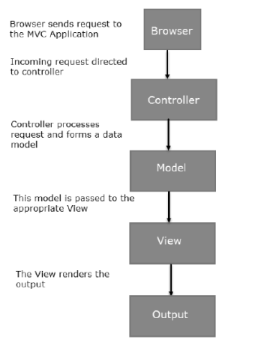

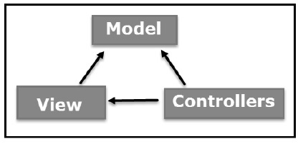 Figure 5.1 MVC

Figure 5.2 MVC Flow Diagram

## SOFTWARE DEVELOPMENT METHODOLOGIES

## Waterfall

Another name of the waterfall model is "Classic Software Development Approach". The basic philosophy in this model is not to move on to the next phase before the end of a phase of projecting. For example: It seems that the development phase cannot be passed before the analysis is completed.

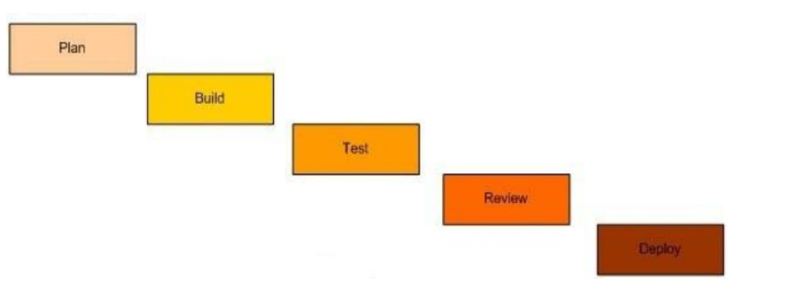

## Scrum

This approach is much less risky than the Waterfall model. In this model, the team focuses on fully tested, independent, value-creating small features. Thus, by distributing the risk, if problems arise while developing a feature, the risk of it preventing the development of other parts is reduced. In this model, iterations called sprints are created and the application can be published if desired at the end of each iteration.

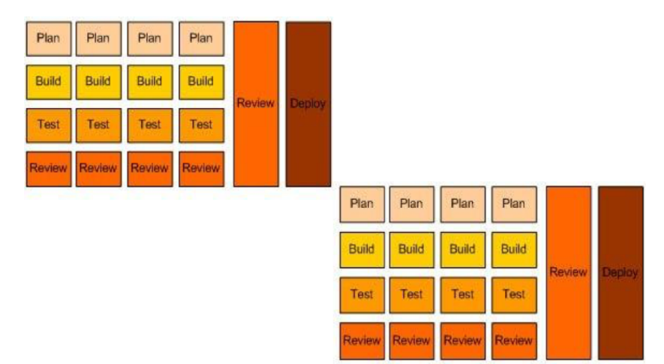

## Agile

Agile method is a special approach to project management used in software development. This method helps teams respond to the unpredictability of software development processes. It uses incremental, iterative work sequences, commonly known as sprints.

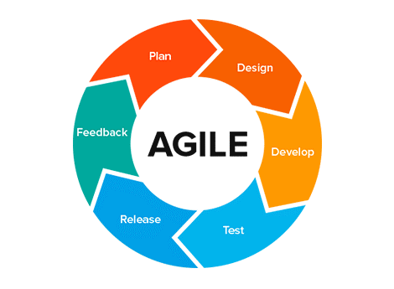

## Logical View

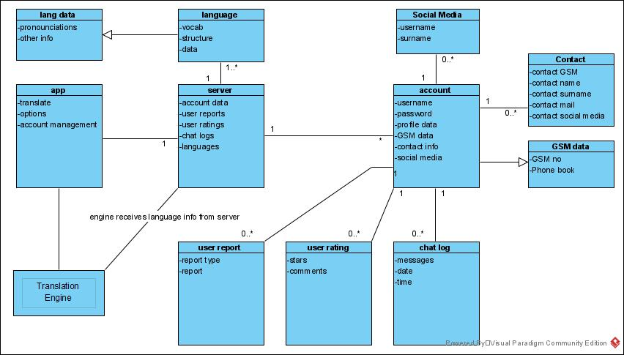

Figure 5.3 Class Diagram

## Deployment View

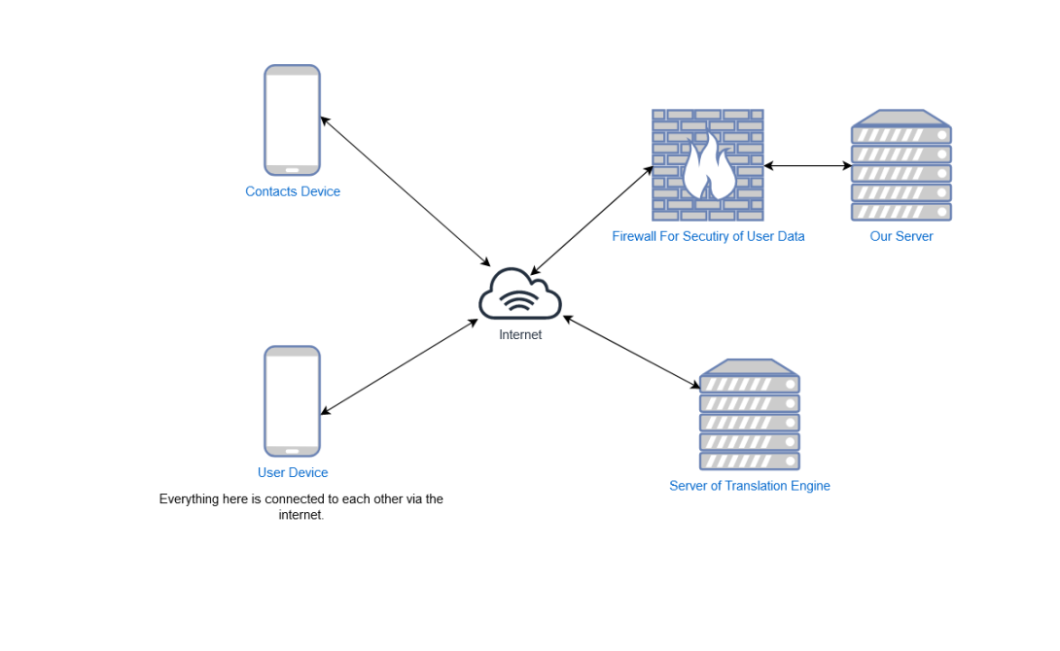

## Use Case View

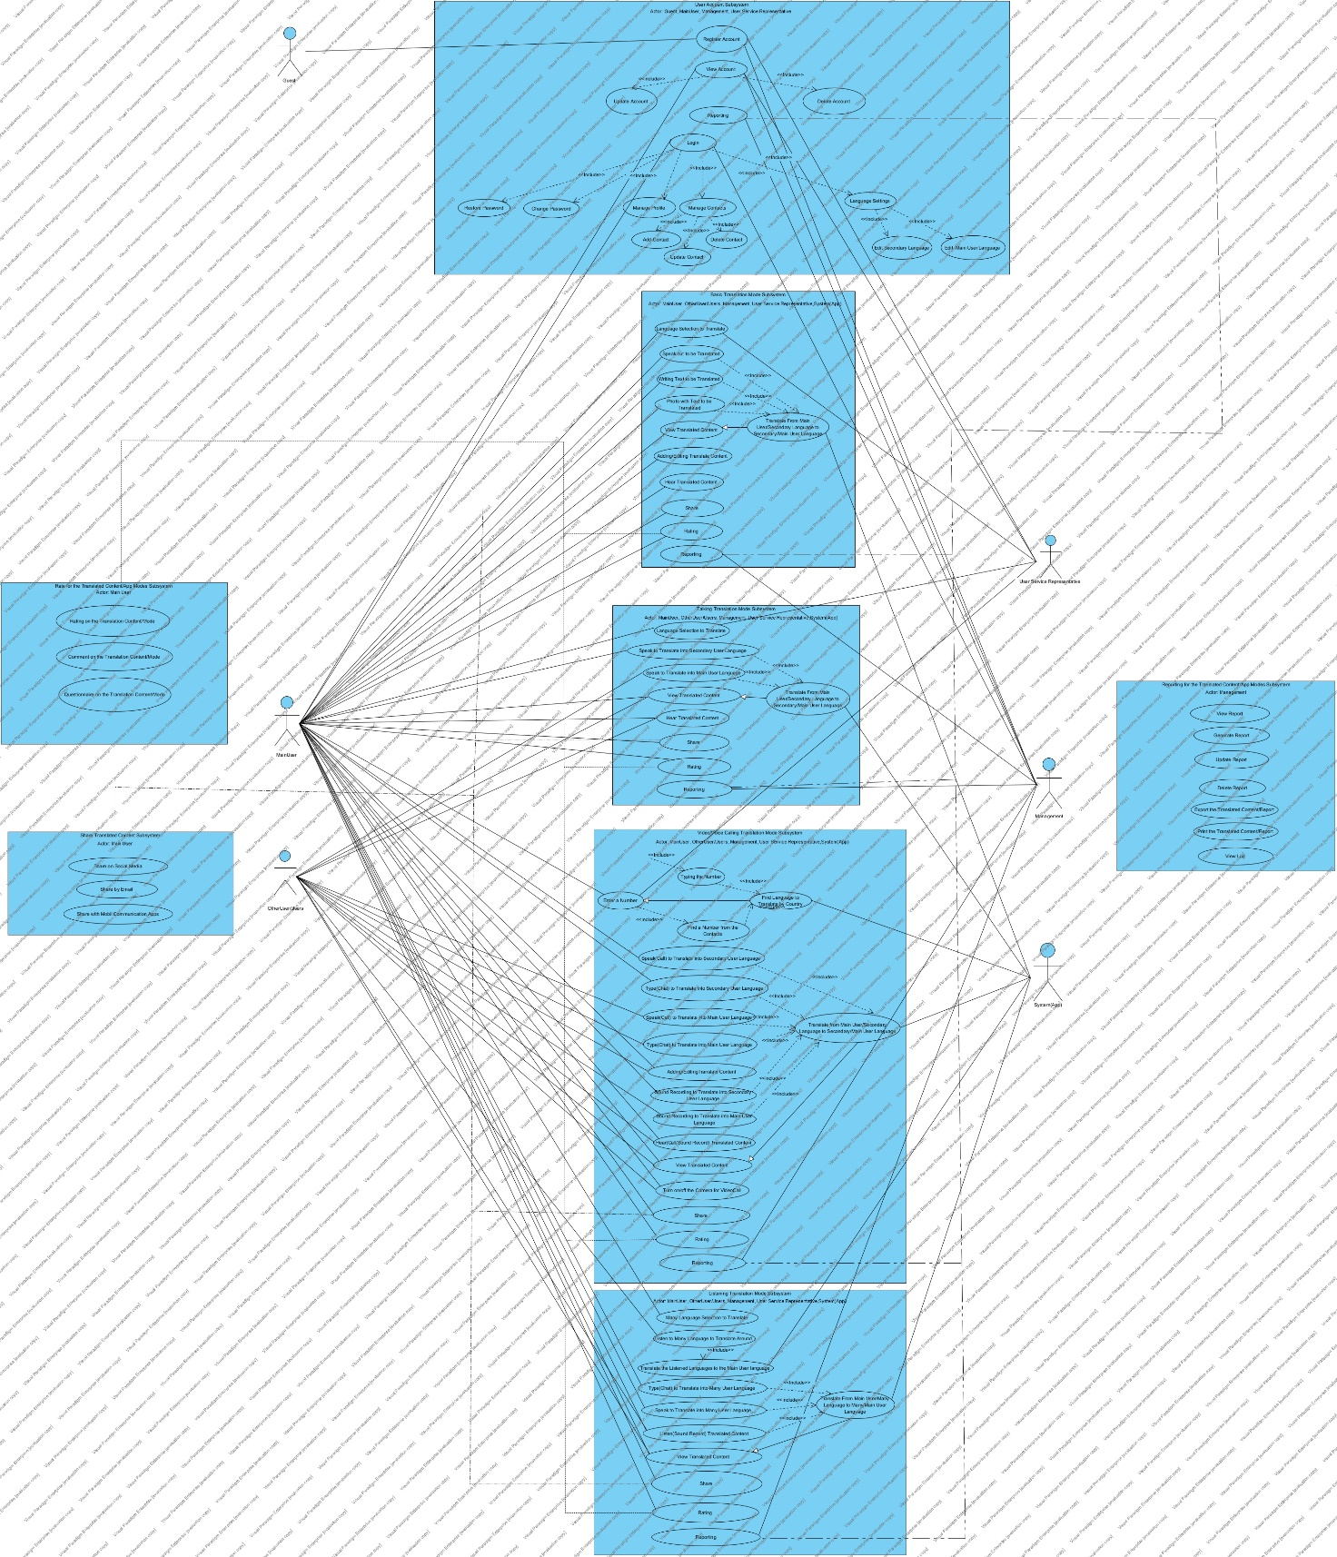

**Original version(Alternative 1):** [**https://ikuedu-my.sharepoint.com/:i:/g/personal/2000006890_stu_iku_edu_tr/EVYcLhxBSw1Jr_Bn7lWK9E4B9VOZA7rOWu9Etzi7iTPXCA?e=CZt8z2**](https://ikuedu-my.sharepoint.com/:i:/g/personal/2000006890_stu_iku_edu_tr/EVYcLhxBSw1Jr_Bn7lWK9E4B9VOZA7rOWu9Etzi7iTPXCA?e=CZt8z2)

**Original version(Alternative 2):** [**https://dosya.co/t4sqodu3l9ne/Use_Case_Diagram.jpg.html**](https://dosya.co/t4sqodu3l9ne/Use_Case_Diagram.jpg.html)

|  |  |
| --- | --- |
| **Actors** | |
| **Actor** | **Description** |
| Guest | People who are likely to be included in the Voice Translation Application. |
| Main User | The person who will install the Voice Translation Application on her/she device and use the system as a basis. |
| Other User/Users | Other people who will use the Voice Translation Application with the main user. |
| User Service Representive | People who help users with the use of the Voice Translation App. |
| Management | People who follow and manage the Voice Translation Application and prepare reports about the system, who ensure that the application is always running. |
| System(App) | Refers to the system of Voice Translation Application. |

|  |  |
| --- | --- |
| **User Account Subsystem** | |
| **Use Case** | **Description** |
| Register Account | Create a user(main user) registration for the use of the application. |
| View Account | View / management of the created user(main user) account and use the usage features based on this situation. |
| Update Account | Updating the created user(main user) account. |
| Delete Account | Deleting the created user(main user) account. |
| Reporting | Management's use of data related to the main user account |
| Login | Created user(main user) can Login to the System and use the usage features based on this situation. |
| Restore Password | Renewing the password of the created user's(main user) account |
| Change Password | Changing the password of the created user's (main user) account |
| Manage Profile | Managing the profile information of the created user's(main user) account (name, surname, phone number, mail ..) |
| Manage Contacts | Management of other phone book that created user can use within the application |
| Add Contact | The created user(main user) adds a contact to the other phone book that can be used in the application. |
| Update Contact | Updating of other phone book contacts that the created user(main user) can use within the application |
| Delete Contact | Deletion of contacts registered in the other phone book that the created user(main user) can use within the application |
| Language Settings | The section where the created user(main user) can edit the language settings that can be used in the application |
| Edit Secondary Language | The created user(main user) can edit the language she/he wants to translate. |
| Edit Main User Language | Created user(main user) can edit her/his own language. |

|  |  |
| --- | --- |
| **Basic Translation Mode Subsystem** | |
| **Use Case** | **Description** |
| Language Selection to Translate | The main user can choose the language she/he wants to translate. |
| Speak out to be Translated | The main user should clearly say the words she/he wants to translate out loud. |
| Writing Text to be Translated | The main user writes the text she/he wants to translate. |
| Photo with Text to be Translated | The main user takes the photo containing the text to be translated from the application with the device camera and uploads it to the system. |
| Translate From Main User/Secondary Language to Secondary/Main User Language | Translating from the main user/secondary language of the system to a secondary/main user language. |
| View Translated Content | Viewing of translated content by the main user |
| Adding/Editing Translate Content | Edit and add content to be translated by the main user. |
| Hear Translated Content | The main user can hear the translated content aloud. |
| Share | Main user's sharing of translated content. |
| Rating | Main user's evaluation of translated content. |
| Reporting | Management's reporting on the main users' use of Simple Translation mode Subsystem. |

|  |  |
| --- | --- |
| **Talking Translation Mode Subsystem** | |
| **Use Case** | **Description** |
| Language Selection to Translate | Main user to choose other user's language. |
| Speak to Translate into Secondary User Language | Speaking by the main user to be translated into the language of the other user. |
| Speak to Translate into Into Main User Language | Speaking by the other user to be translated into the main user language. |
| Translate From Main User/Secondary Language to Secondary/Main User Language | Translating from the main user/other user language of the system to other/main user language. |
| View Translated Content | Users to see the translation content. |
| Hear Translated Content | Users to hear the translation content aloud. |
| Share | Share of translation content by main user. |
| Rating | Main user evaluate translated content. |
| Reporting | Management's reporting on users' use of Talking Translation Mode Subsystem. |

|  |  |
| --- | --- |
| **Video/Voice Calling Translation Mode Subsystem** | |
| **Use Case** | **Description** |
| Enter a Number | The main user enters the number she/he wants to call. |
| Typing the Number | Main user typing in the number she/he wants to start a call |
| Find a Number from the Contacts | The main user can find the number she/he wants to call from the application directory they have previously saved. |
| Find Language to Translate by Country | Finding the number that the main user wants to call according to the number area code of the system(App). |
| Speak(Call) to Translate into Secondary User Language | Speaking of the main user to be translated into other user language for voice communication with the other user |
| Type(Chat) to Translate into Secondary User Language | Writing to be translated into other user language for the main user to provide written communication with the other user. |
| Speak(Call) to Translate into Main User Language | The speech of the other user to be translated into the main user language for voice communication with the main user. |
| Type(Chat) to Translate into Main User Language | Writing to be translated into the main user language for the other user to provide written communication with the main user. |
| Adding/Editing Translate Content | Edit and add content to be translated by the main user and other user. |
| Sound Recording to Translate into Secondary User Language | Translation of the speech of the main user in the form of an audio recording into the language of the other user. |
| Sound Recording to Translate into Main User Language | Translation of the speech of the other user in the form of an audio recording into the language of the main user. |
| Translate From Main User/Secondary Language to Secondary/Main User Language | Translating from the main user/other user language of the system to other/main user language. |
| Hear(Call/Sound Record) Translated Content | The users can hear their own voices as well as the translated voices in the call and in the voice recordings. |
| View Translated Content | Users to view translated content. |
| Turn on/off the Camera for VideoCall | Users can turn their cameras on and off to start or end a video call |
| Share | Share of translation content by main user. |
| Rating | Main user evaluate translated content. |
| Reporting | Management's reporting on users' use of Video/Voice Calling Translation Mode Subsystem |

|  |  |
| --- | --- |
| **Listening Translation Mode Subsystem** | |
| Many Language Selection to Translate | If the main user wants to communicate with more than one person, the language of the other users concerned should be specified. |
| Listen to Many Language to Translate Around | Main user allowing other users to hear. |
| Translate the Listened Languages to the Main User Language | Translation of languages listened to from other users into the main user language. |
| Type(Chat) to Translate into Many User Language | Typing to be translated into predetermined languages by the main user. |
| Speak to Translate into Many User Language | Speaking to be translated into predetermined languages by the main user. |
| Listen(Sound Record) Translated Content | Users can listen to the voices they speak |
| View Translated Content | Users to view translated content. |
| Share | Share of translation content by main user. |
| Rating | Main user evaluate translated content. |
| Reporting | Management's reporting on users' use of Listening Translation Mode Subsystem. |

|  |  |
| --- | --- |
| **Rate for the Translated Content/App Modes Subsysem** | |
| **Use Case** | **Description** |
| Rating on the Translation Content/Mode | The main user evaluates the translated content/app mode (star rating, likes, dislikes ...). |
| Comment on the Translation Content/Mode | Main user commenting on translated content/app mode. |
| Questionnaire on the Translation Content/Mode | Main user participating in surveys for translated content/app mode. |

|  |  |
| --- | --- |
| **Share Translated Content Subsystem** | |
| **Use Case** | **Description** |
| Share on Social Media | The main user sharing the translated content on social networks(Facebook, Twitter, Linkedin). |
| Share by Email | Main user sharing the translated content by e-mail. |
| Share with Mobil Communication Apps | Main user's sharing of translated content with mobile device applications (Whatsapp / Telegram / ..) |

|  |  |
| --- | --- |
| **Reporting for the Translated Content/App Modes Subsystem** | |
| **Use Case** | **Description** |
| Generate Report | Management's report on translated contents / application mode. |
| Update Report | Management's updating of existing reports on translated content / application mode. |
| Delete report | Management deletes existing reports about translated content / application mode |
| Export the translated content/report | Management's export of existing reports or translated contents about translated contents / application mode with different file types. |
| Print the translated content/report | Printing existing reports or translated content about the translated contents / application mode of the administration. |
| View Log | Management's sub-systems to see all system login processes. |

## Use Case Scenarios

|  |
| --- |
| Case: Register |
| As a user, I want to register to use Voice Translation App. |
| Acceptance Criteria:  -The application must be downloaded.  -Username, password and e-mail address must be provided. Telephone number can be preferred instead of e-mail address.  -The password must be at least 8 characters and contain at least 1 digit, 1 letter, 1 uppercase letter, 1 lowercase letter, 1 special character.  -Mandatory fields must be filled.  -Optional fields such as age, gender, location can be filled. |

|  |
| --- |
| Case: Login |
| As a user, I want to login to use Voice Translation App. |
| Acceptance Criteria:  -The user's account information must be known.  -The user must be registered in the system. |

|  |
| --- |
| Case: View Account |
| As a user, I want to see my account details to manage it. |
| Acceptance Criteria:  -Login to the system must be done.  -Fields must be viewable to manage information.  -The user should be able to update the account whenever he/she want.  -The user should be able to delete the account whenever he/she want.  - When the user edits information, then the information should be edited. |

|  |
| --- |
| Case: Restore/Change Password |
| As a user, I want to restore/change my password whenever I see it necessary. |
| Acceptance Criteria:  -The old password must be known.  -Must be at least 8 characters.  -Must contain at least 1 digit.  -Must contain at least 1 letter.  -Must contain at least 1 uppercase letter.  -Must contain at least 1 lowercase letter.  -Must contain at least 1 special character.  -When the user edits information, then the information should be edited. |

|  |
| --- |
| Case: Manage Profile |
| As a user, I want to manage my profile when I see it necessary. |
| Acceptance Criteria:  -The areas where the information will be managed should be able to be displayed on the screen.  -Mandatory and optional fields should be manageable.  -The information should be able to be changed or deleted whenever the user want. |

|  |
| --- |
| Case: Manage Contact |
| As a user, I want to manage the information of the people I will communicate with. |
| Acceptance Criteria:  -Previously added contacts should be displayed on the screen.  -The user should be able to update the information of previously added contacts (name, surname, phone number...)  -The user should be able to add a new contact.  -The user must be able to delete the cantacts.  -Changed or newly added information must be saved in the system. |

|  |
| --- |
| Case: Language Setting |
| As a user, I want to set the language options to translate from my language to another language. |
| Acceptance Criteria:  -The user must be able to see the languages provided by the system in order to choose his/her own language and target language.  -The user should be able to choose their native language from the system.  -The user should be able to choose their native language from the system.  -After the selection is completed, the settings should be saved to the system. |

|  |
| --- |
| Case: Speak out to be Translated |
| As a user, I want to translate by verbal for quick translation. |
| Acception Criteria:  -Language options provided by the system should be displayed on the screen.  -The user must choose language pairs.  -The main user should clearly say the words she/he wants to translate out loud.  -Translating from the main user language to secondary language or from secondary language to main user language.  -Translated content must be visible to the main user.  -Translated content must be edited by the main user.  -The main user should be able to listen to the translated content.  -The user can share translated content.  -The user can rate the translated content.  -Management can report users' usage of this system. |

|  |
| --- |
| Case: Writing Text to be Translated |
| As a user, I want to translate by text. |
| Acception Criteria:  -Language options provided by the system should be displayed on the screen.  -The user must choose language pairs.  -The user must type the text that he/she want to translate.  - Translating from the main user language to secondary language or from secondary language to main user language.  -Translated content must be visible to the main user.  -Translated content must be edited by the main user.  -The main user should be able to listen to the translated content.  -The user can share translated content.  -The user can rate the translated content.  -Management can report users' usage of this system. |

|  |
| --- |
| Case: Photo with Text to be Translated |
| As a user, I want to translate text for example by taking a photo from a book. |
| Acceptance Criteria:  -Language options provided by the system should be displayed on the screen.  -The user must choose language pairs.  -The user must take the photo of the text that he/she wants translated and upload it to the system.  -The photo must be readable and clear for accurate translation.  - Translating from the main user language to secondary language or from secondary language to main user language.  -Translated content must be visible to the main user.  -Translated content must be edited by the main user.  -The main user should be able to listen to the translated content.  -The user can share translated content.  -The user can rate the translated content.  -Management can report users' usage of this system. |

|  |
| --- |
| Case: Voice/Video Calling Translation Mode |
| As a user, I want to make a phone call with someone who speaks another language for a job interview. |
| Acception Criteria:  -Language options provided by the system should be displayed on the screen.  -The user must choose language pairs.  -The main user can enter the number of the other user to make a call or select a registered user from the phone book.  -The conversations of the main user are translated into the language of the other user by the system.  -The translated conversations are transmitted to the other user by the system.  -Other user's conversations are translated into the main user's language by the system.  -Conversations translated from the other user are transmitted to the main user by the system.  -The users must also view the translated conversations in writing on the screen.  -Users can turn their cameras on and off to start or end a video call.  -Conversations can be recorded in audio recording form for later listening.  -The user can share translated content.  -The user can rate the translated content.  -Management can report users' usage of this system. |

|  |
| --- |
| Case: Talking Mode |
| As a user, I want to be able to talk face to face with someone who speaks a different language. |
| Acceptance Criteria:  -Language options provided by the system should be displayed on the screen.  -The user must choose language pairs.  -For this case, users must be physically side by side.  -The conversations of the main user are translated into the language of the other user by the system.  -These translations are voiced by the system for the other user to hear.  -Other user's conversations are translated into the main user's language by the system.  -These translations are voiced by the system for the main user to hear.  -The users must also view the translated conversations in writing on the screen.  -The user can share translated content.  -The user can rate the translated content.  -Management can report users' usage of this system. |

|  |
| --- |
| Case: Listening Translation Mode |
| As a user, I want to be able to communicate in a crowded environment where I don't know the language spoken, so that I can feel more comfortable when traveling abroad. |
| Acceptance Criteria:  -If communication is to be made with more than one person, languages should be specified.  -The system must be able to listen to the surrounding sounds.  -The system translates expressions in the languages spoken around into the language of the main user.  -The main user can write a message to be translated into different languages in the environment.  -The main user can speak in the environment to be translated into different languages.  -The system should translate verbal or written statements from the main user into target languages.  -These translated phrases are voiced by the system.  -The users must also view the translated conversations in writing on the screen.  -The user can share translated content.  -The user can rate the translated content.  -Management can report users' usage of this system. |

|  |
| --- |
| Case: Rate for the Translated Content/App Modes |
| As a user, I want to rate the services of the system so that I can show whether I like the application or not. |
| Acceptance Criteria:  -The main user can evaluate the translated content/app mode. (star rating, likes, dislikes...)  -The main user can comment on translated content/app mode.  -The main user can participate in surveys for translated content/app mode. |

|  |
| --- |
| Case: Share Translated Content |
| As a user, I want to share the translated documents with my friends. |
| Acceptance Criteria:  -The main user can share the translated content on social media platforms.  -The main user can share the translated content by e-mail.  -Sharing options should be able to be displayed on the screen. |

|  |
| --- |
| Case: Reporting for the Translated Content/App Modes |
| As a user service representative/management, I want to report usage to develop a better service. |
| Acceptance Criteria:  -A management report can be created about the translated content / application mode.  -Management's existing reports on translated content / application mode can be updated.  -Management can delete existing reports on translated content / application mode.  -Management's existing reports or translated content about content / application mode translated with different file types can be exported.  -The administration's existing reports or translated content about translated content / application mode can be printed.  -All system login processes can be viewed by the management subsystems. |

# DESIGN AND IMPLEMENTATION

